**Lab1 – Creating Virtual Machine - Windows in Azure**

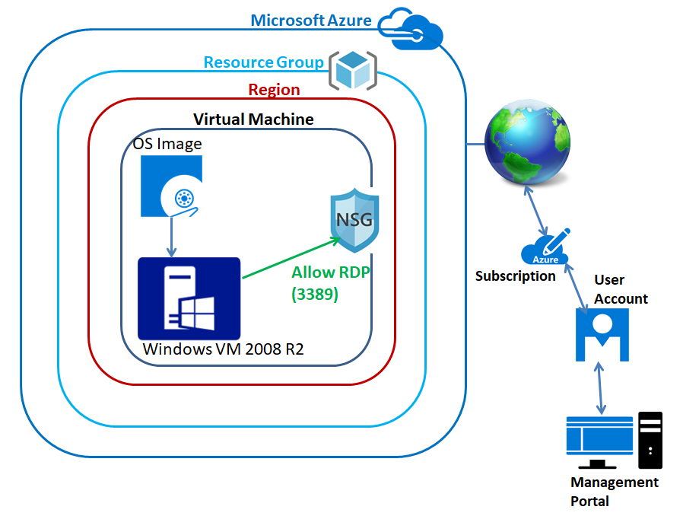

**Login to** [**https://portal.azure.com**](https://portal.azure.com) **with outlook login credentials.**

**Click option button on “Dashboard” and click “Save”.**

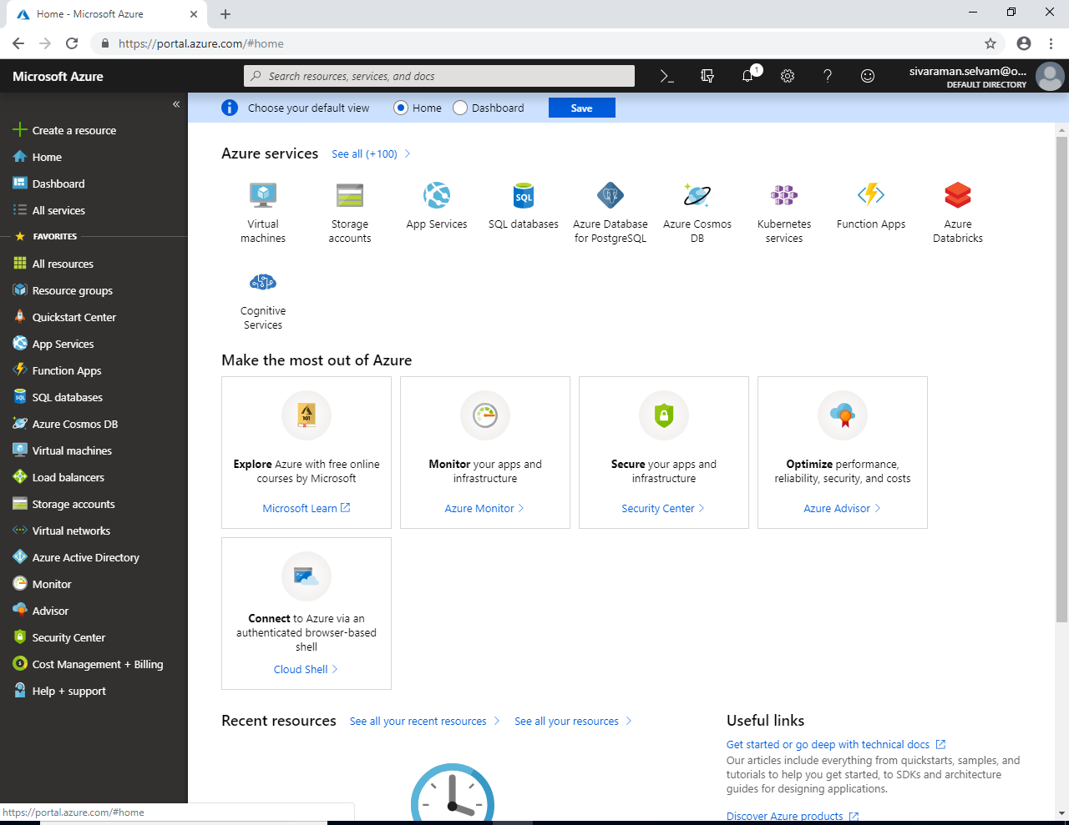

**Now we have required to create a resource group first to create a Virtual machine in Azure.**

**Click “Resource Groups” in Left side to create a “Resource Group”.**

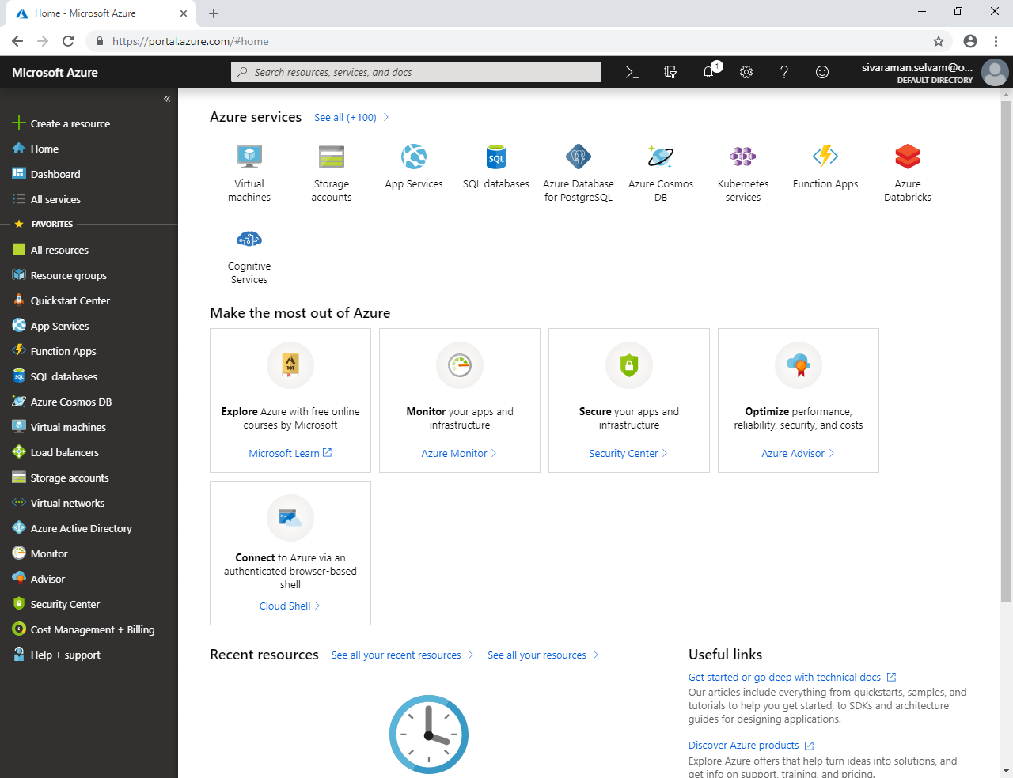

**In Resource groups,**

**Click “Add” to create a new Resource groups.**

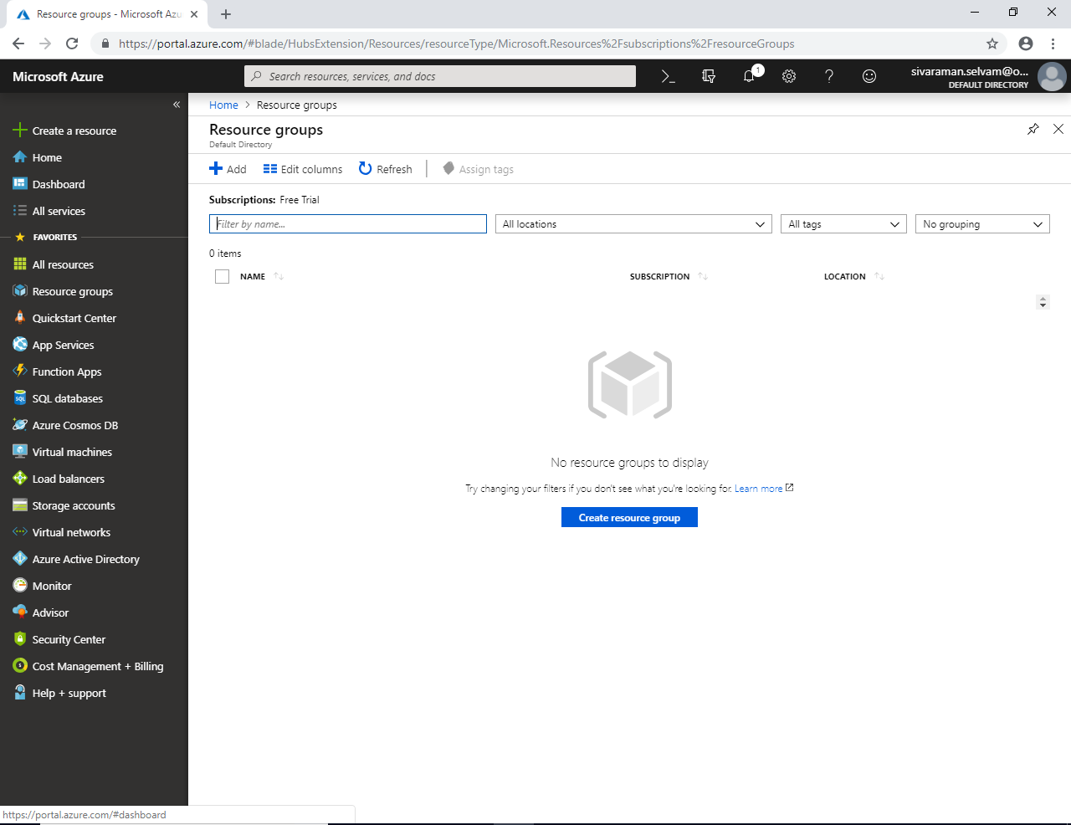

**While creating Resource group it has required “Resource group name”**

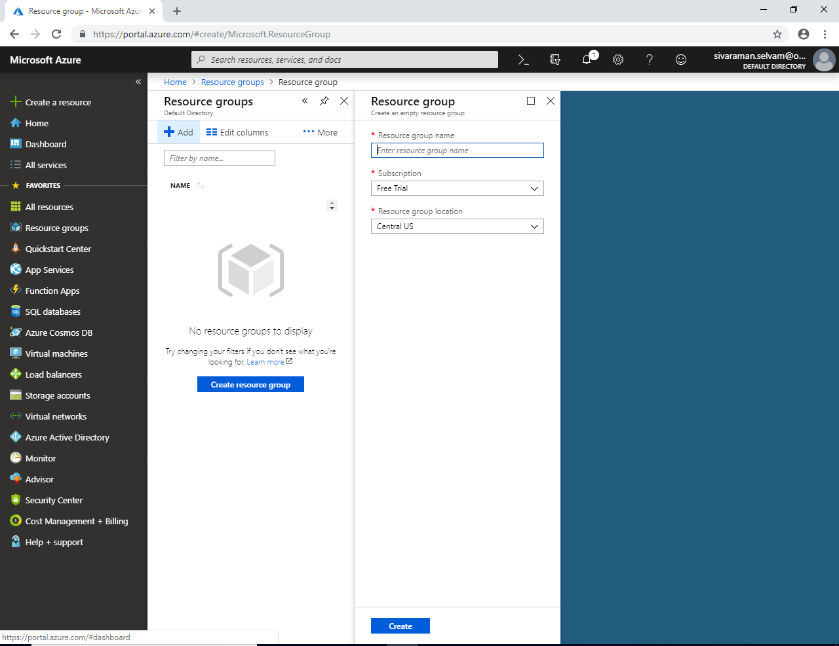

**Type “Resource Group” name as “SansboundAzureClass”.**

**“Subscription” should be as “Free Trial”.**

**“Resource group Location” should be as your choice / business requirement. As of now I will leave this as default.**

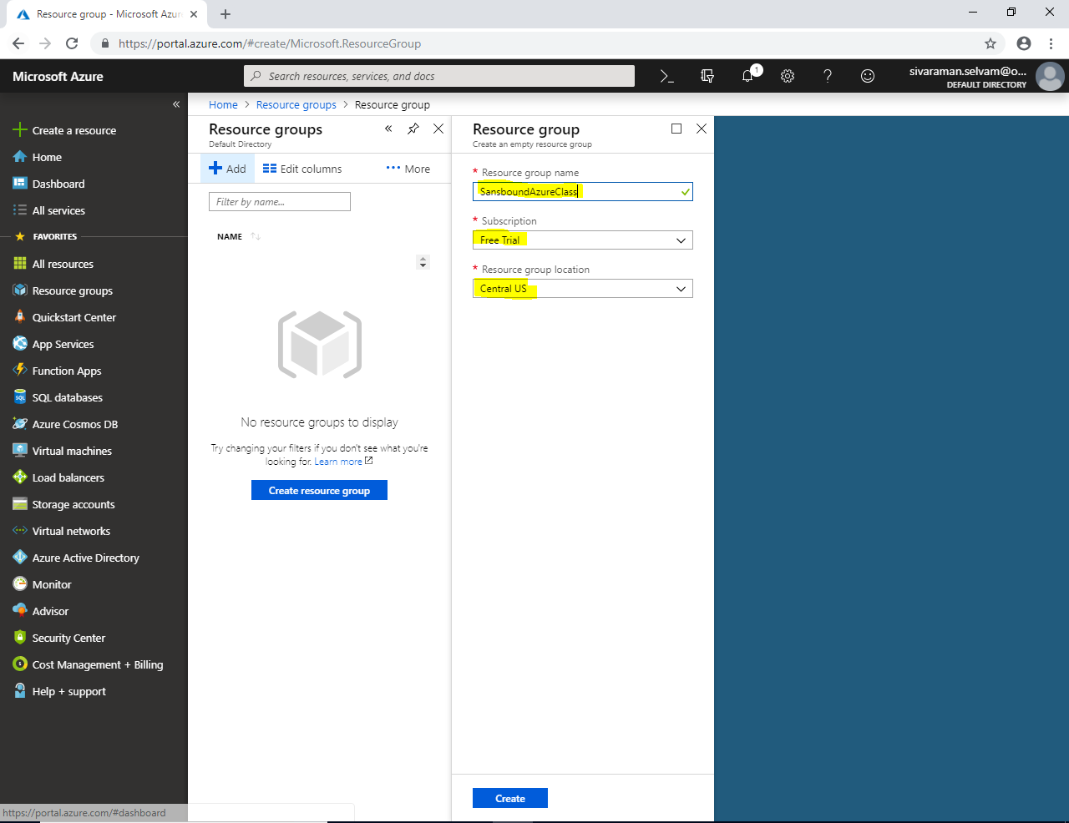

**Then click “Create” to create the “Resource Group”.**

**Click “Refresh” to get the Resource group which we have created.**

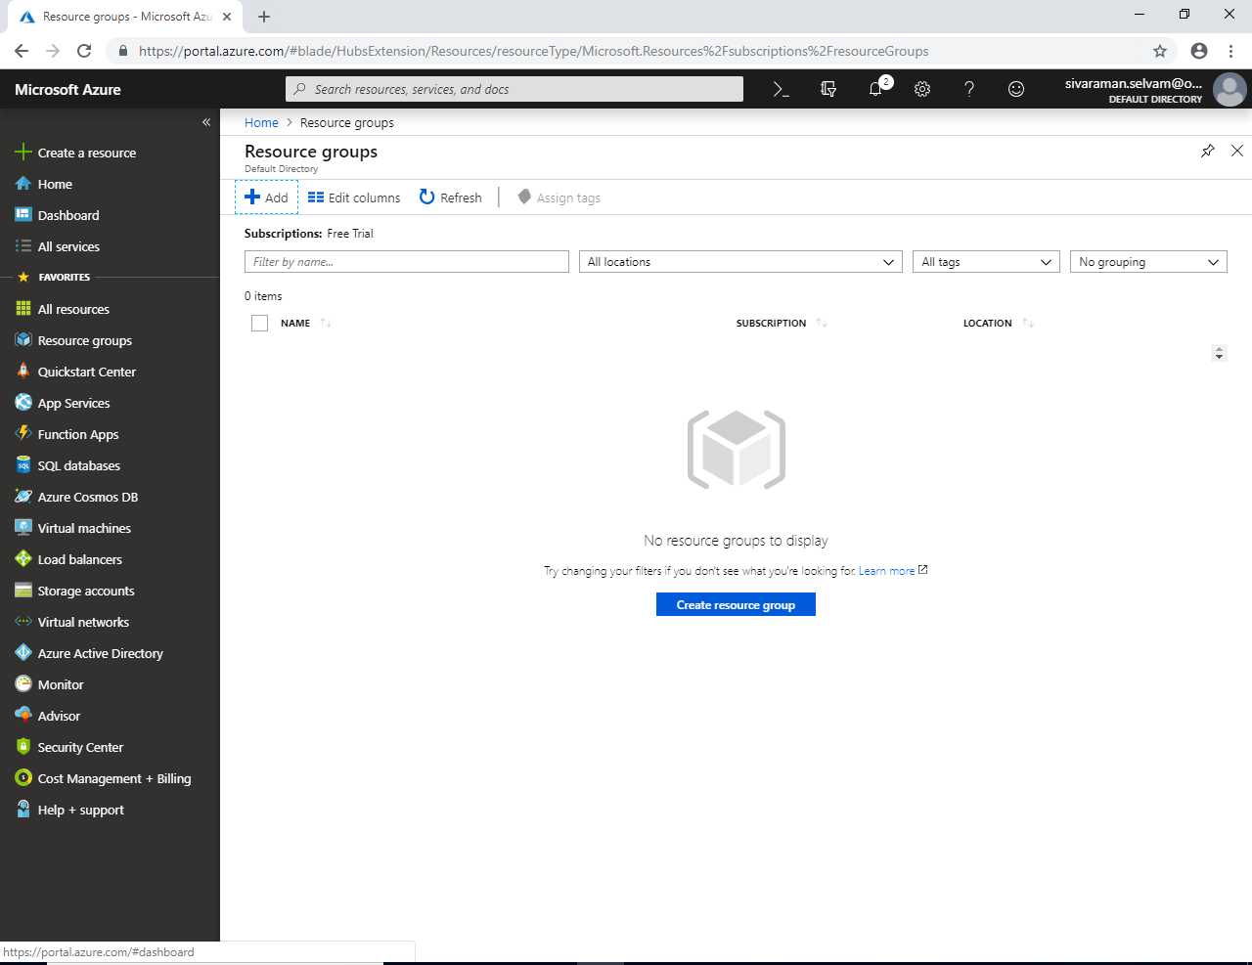

**Now you are able to see the “Resource Group” which you have created as “SansboundAzureClass”.**

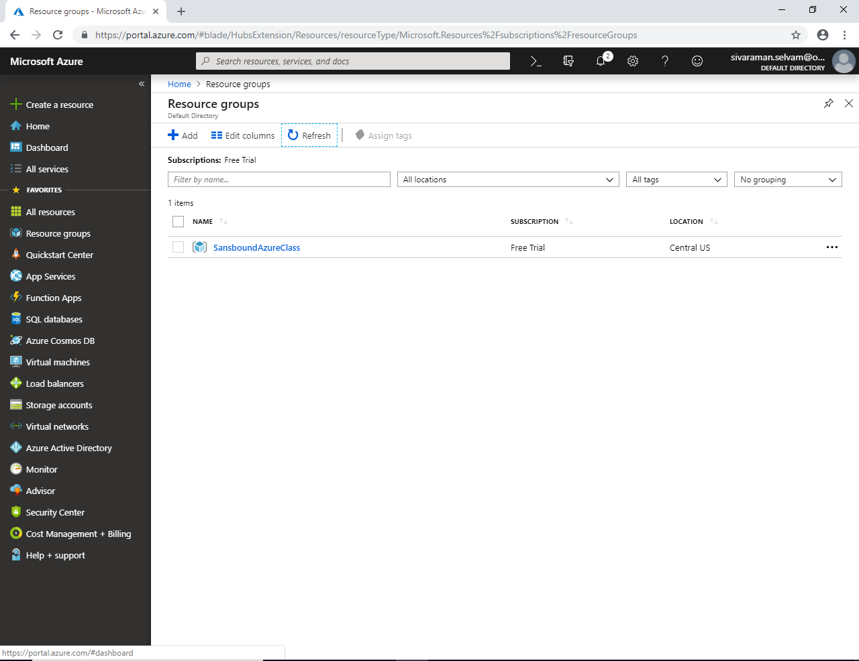

**In Dashboard, click “Virtual machines” in Left side under Favourites.**

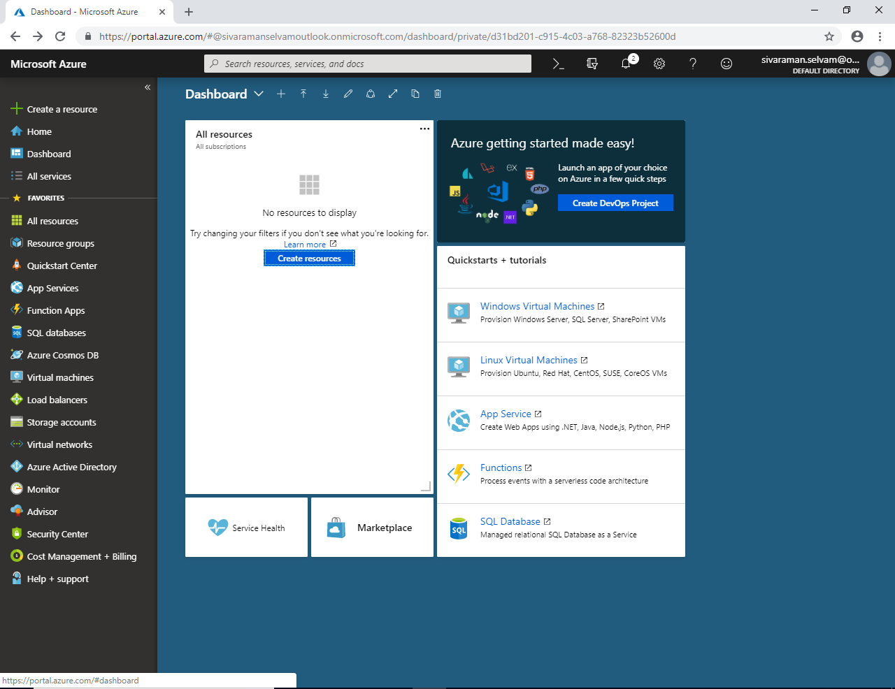

**In “Virtual machines” Click “Add” to create new virtual machine.**

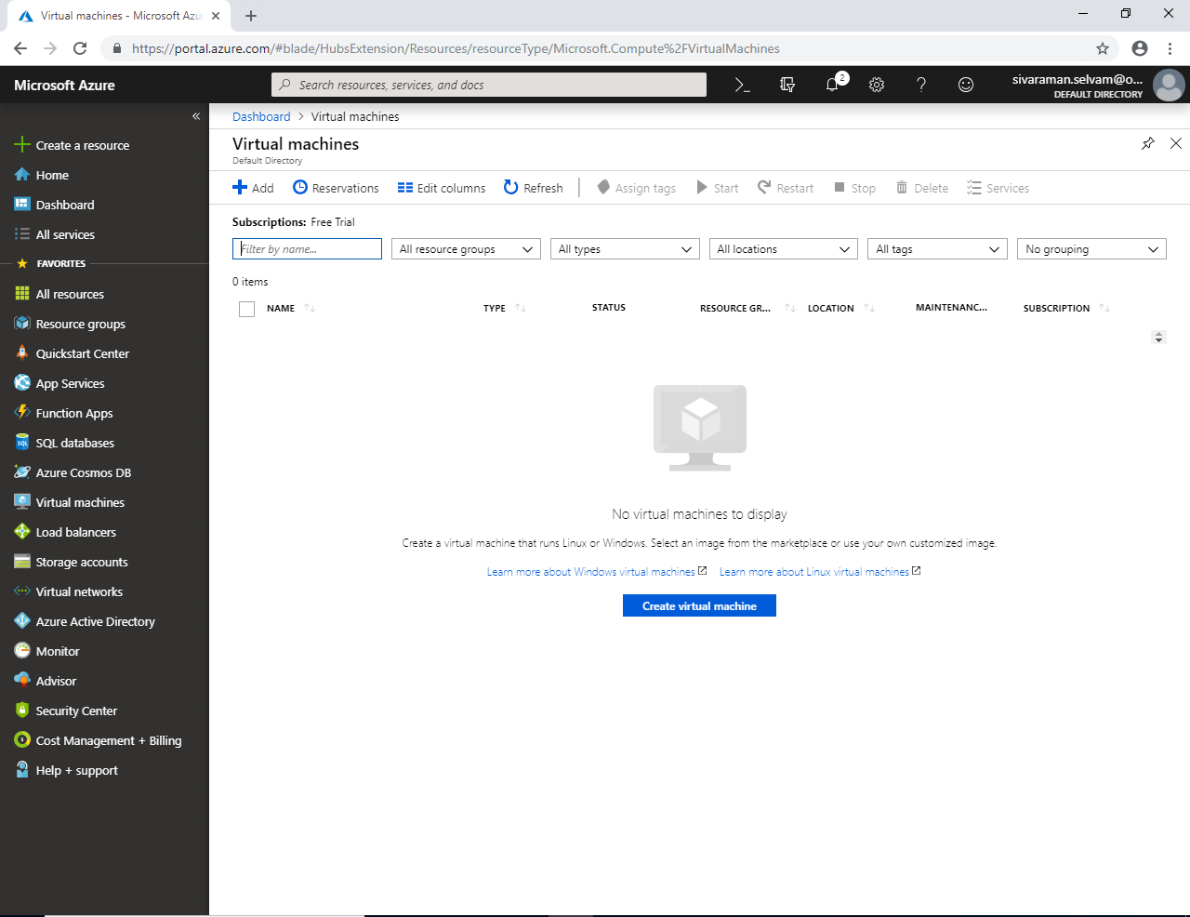

**While creating Virtual Machine we have required to provide below mentioned details**

1. **Select the “Subscription” as “Free Trial”.**
2. **Select the “Resource Group” as “SansboundAzureClass”.**
3. **Specify the Virtual machine name as “WindowsVM-Azure”.**
4. **Specify the region as your business requirement, i will leave default region at this stage.**
5. **Select the Image as “Windows Server 2008 R2 SP1”.**
6. **By default Virtual machine size will be selected as Standard DS1 V2 (with 1 vCPU & 3.5 GB RAM). But we need to select Free Trial Virtual machine Type B1S.**

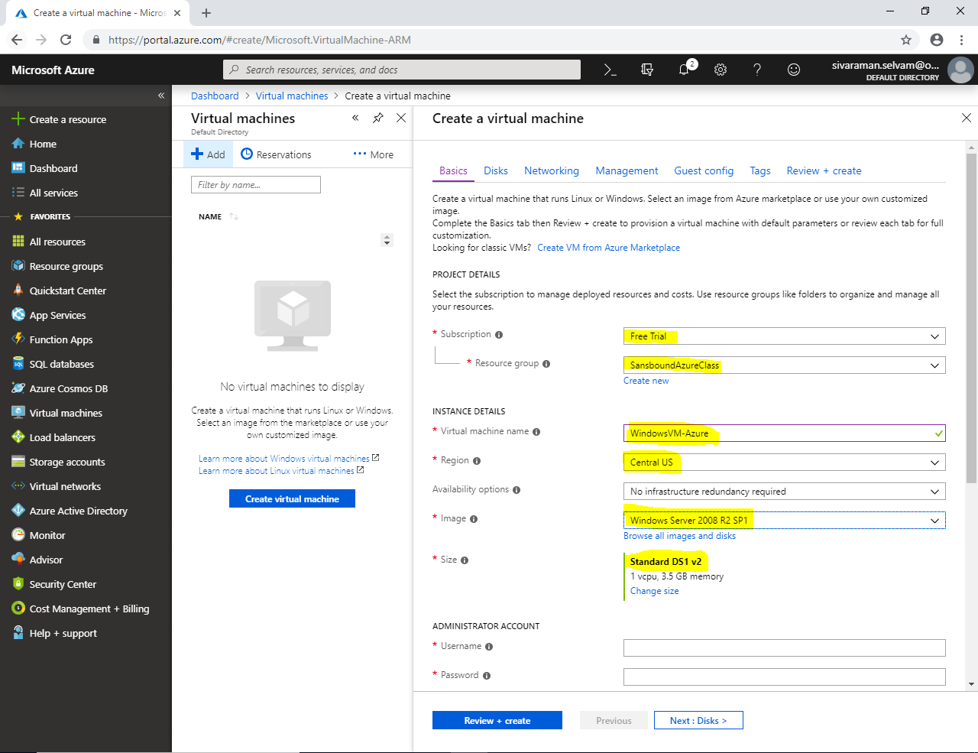

**In Size, click “Change Size”**

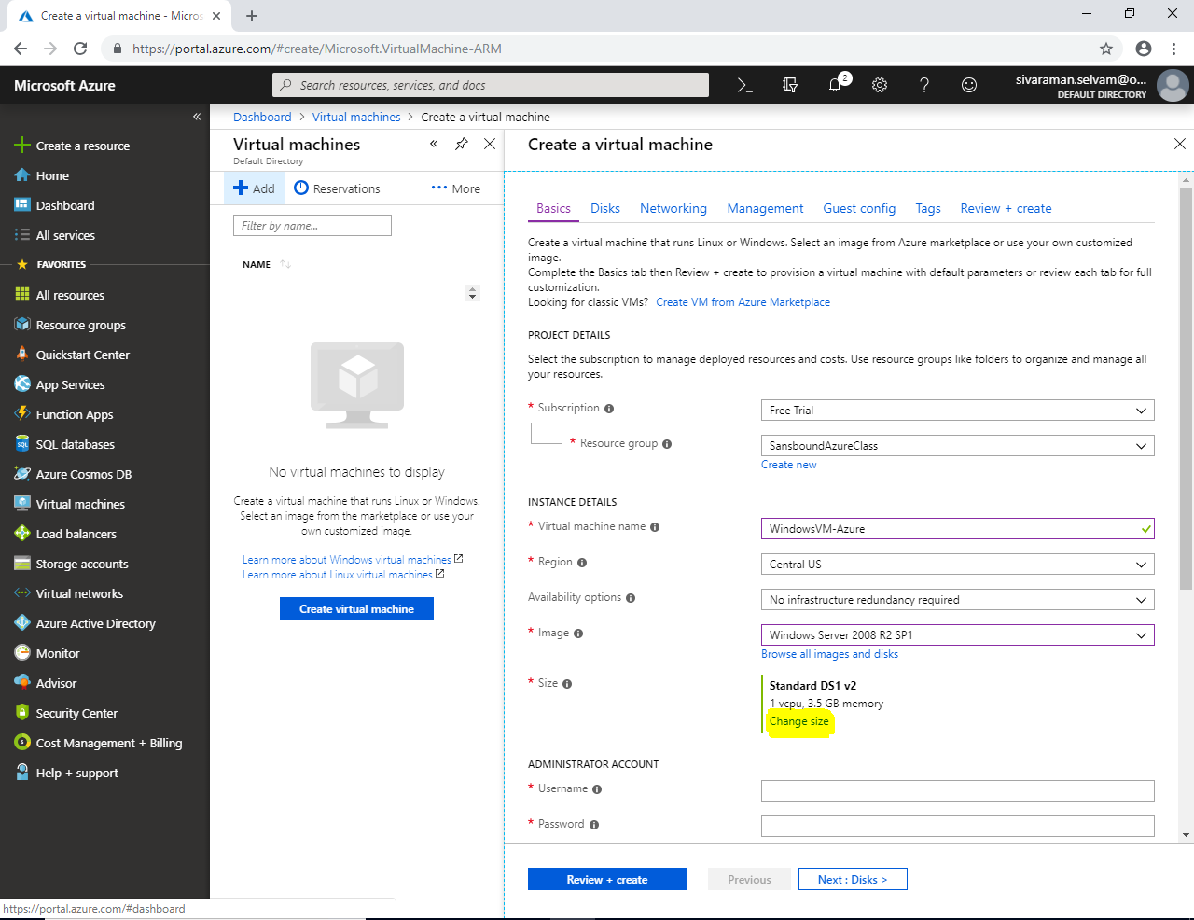

**Select the Virtual size as Standard “B1s” then click “Select” button in bottom.**

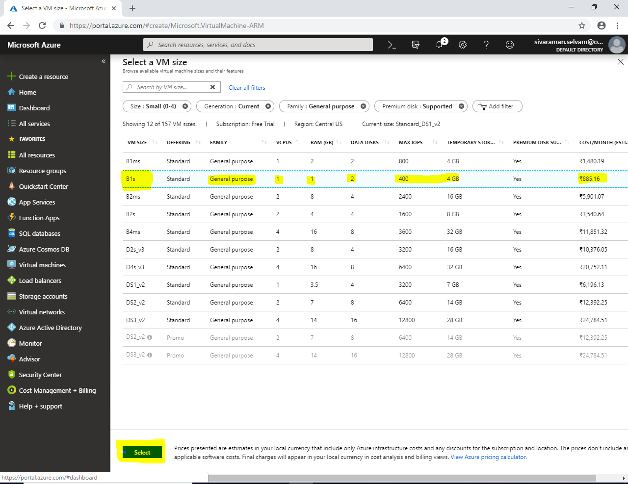

**You need to ensure that VM Size is “Standard B1s”.**

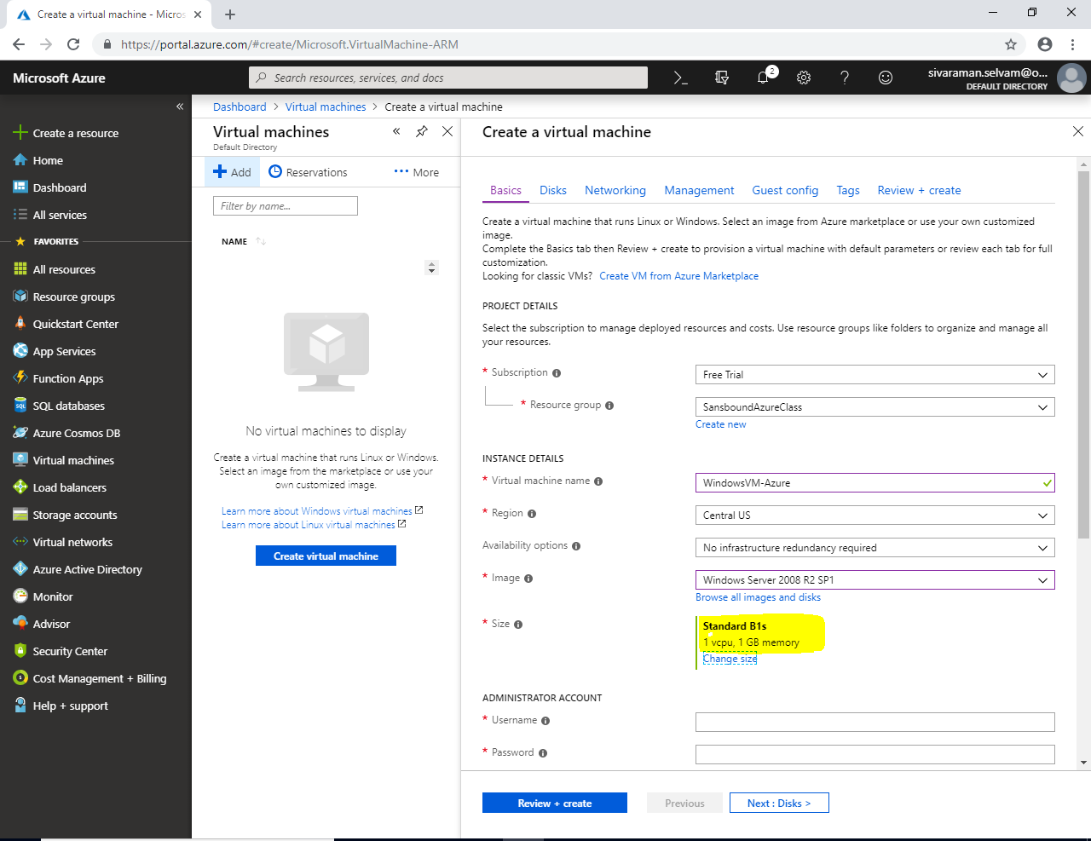

**In “Administrator Account”, I will type type username which has required built-in administrator privilege. I have type as “sansbound”. You can specify the user name as per your wish.**

**In password, password must have 1 upper case character , 1 lower case character and and 1 number and 1 special character. Also password length should be minimum 12 characters maximum 72 characters.**

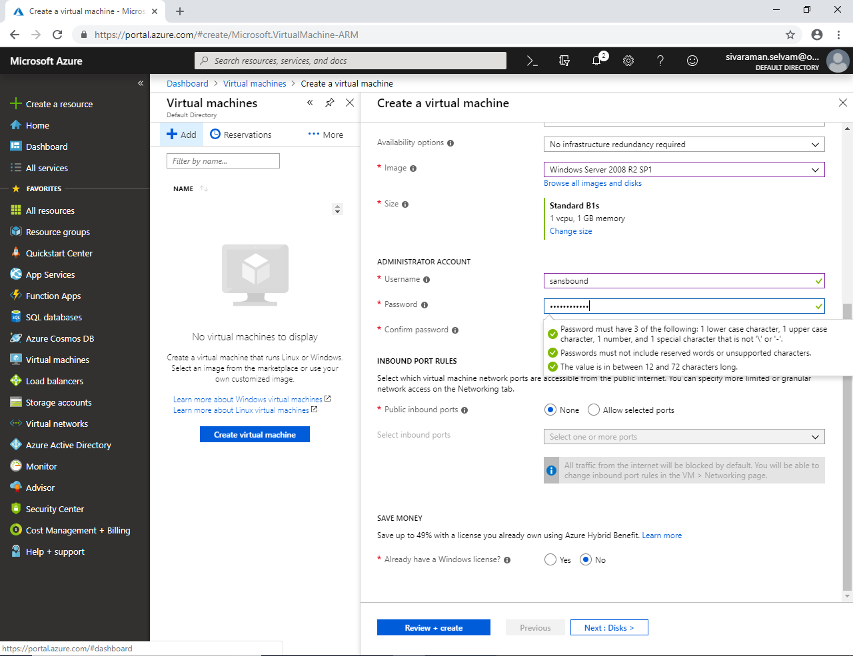

**In “Inbound Port Rules”, by default it has been set as “None”.**

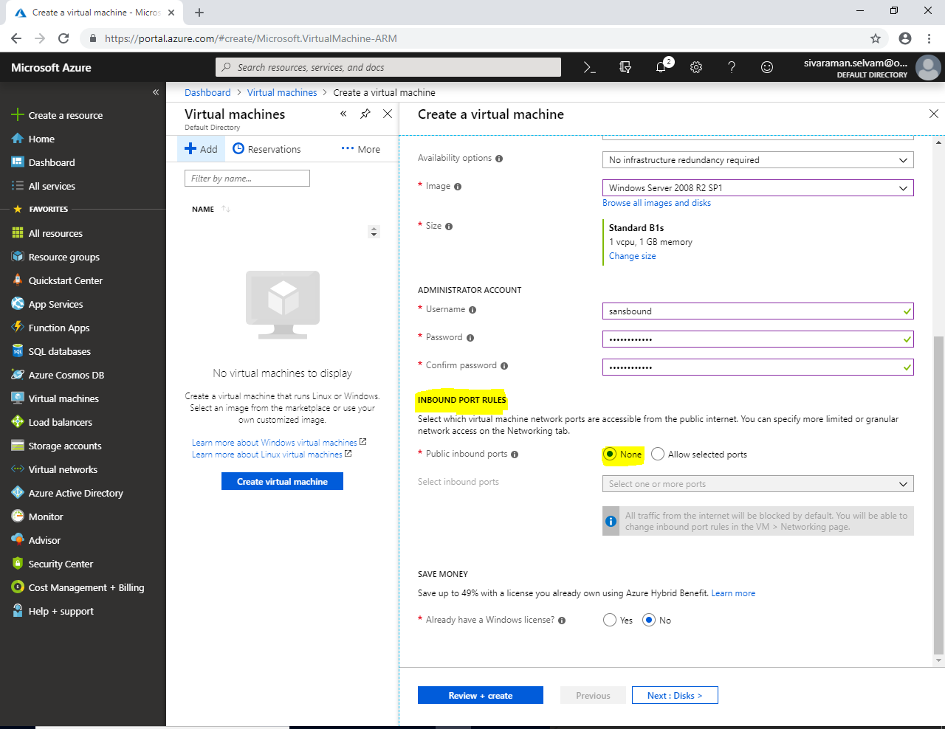

**But we have required to allow specific ports by click “Allow Selected Ports” manually.**

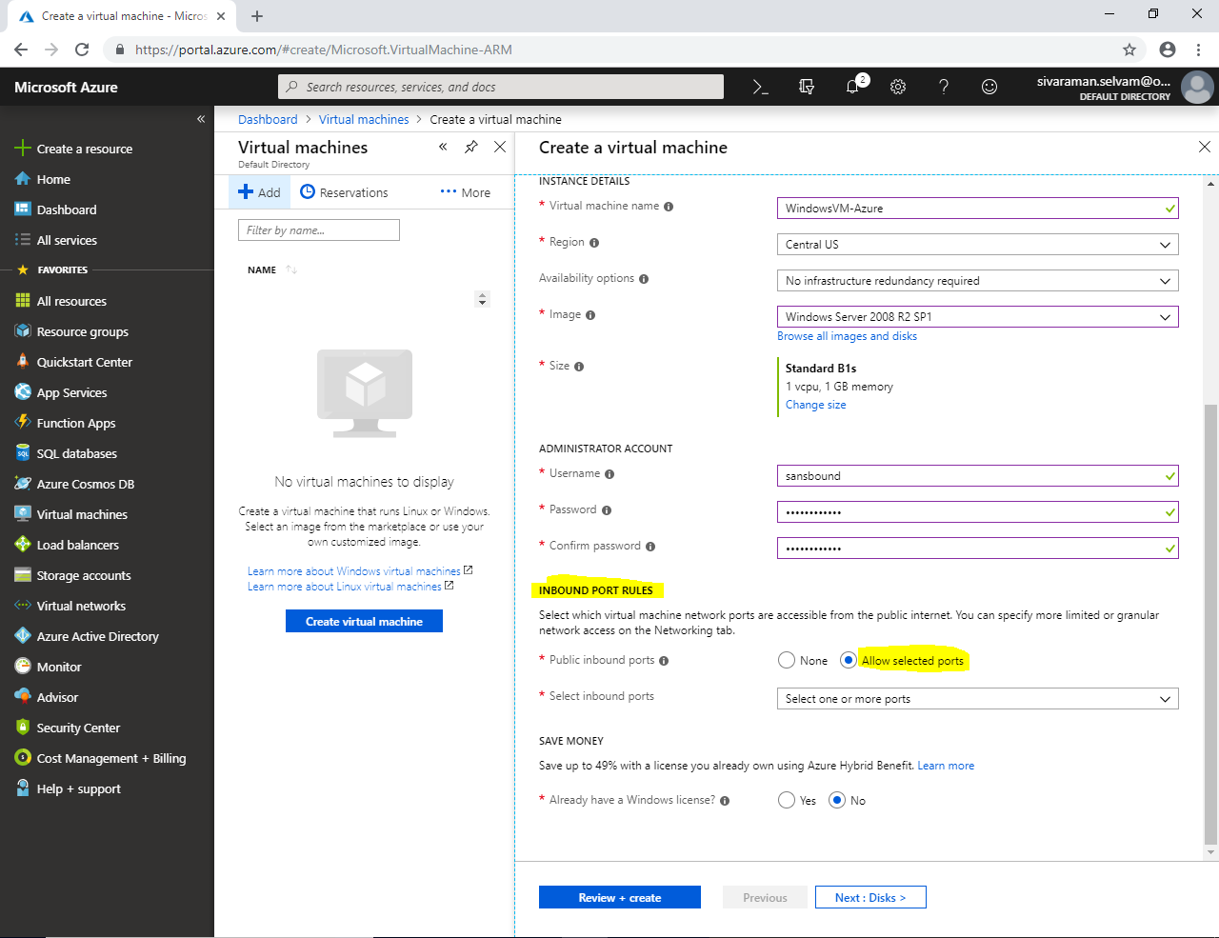

**In “Inbound Port Rules”, click “Allow Selected Ports”.**

**Then click “Select one or more ports” drop down box.**

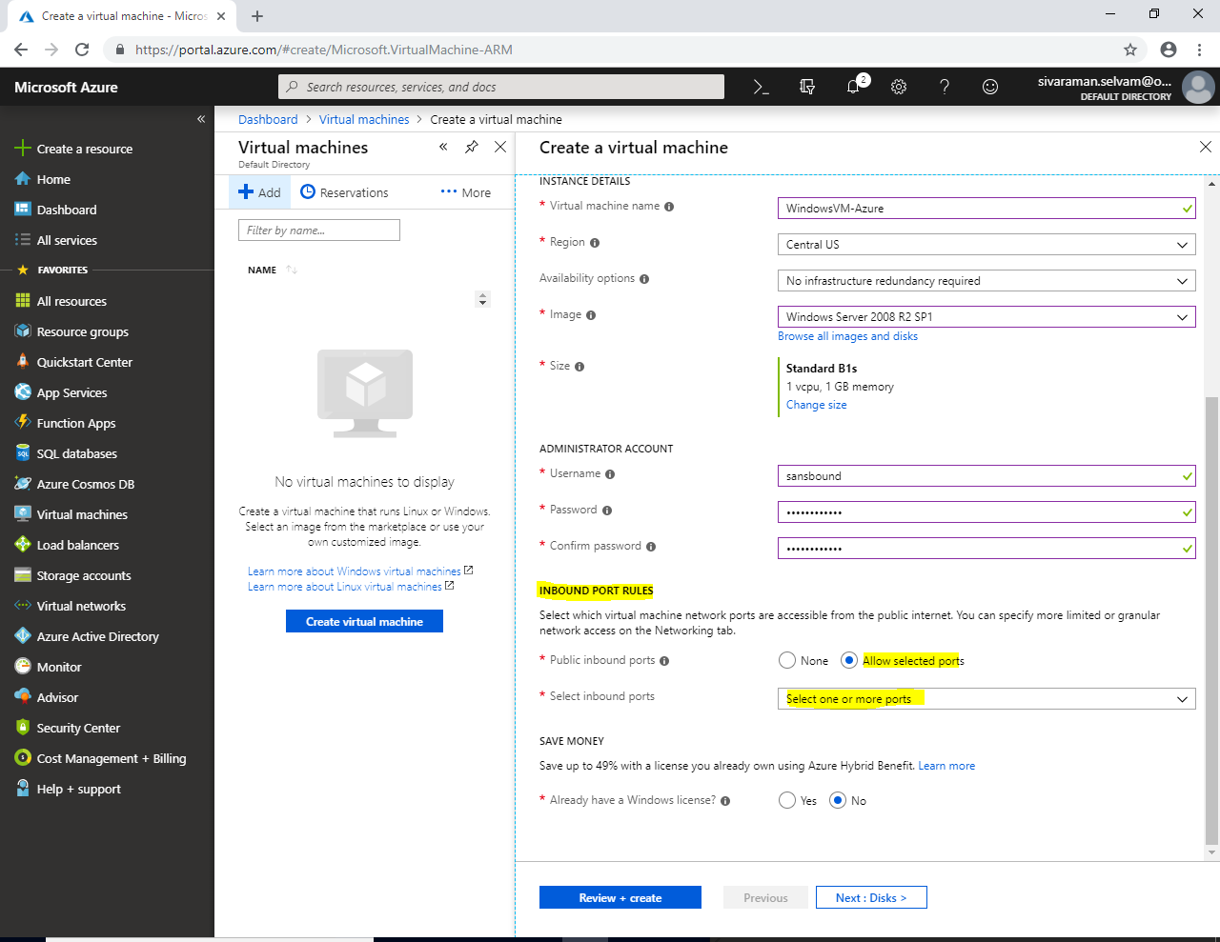

**As of now, I have created Windows Virtual machine for that I have required Port 3389 (RDP) to Allow for access the server remotely.**

**You need to check the “RDP (3389)” in Inbound Rule.**

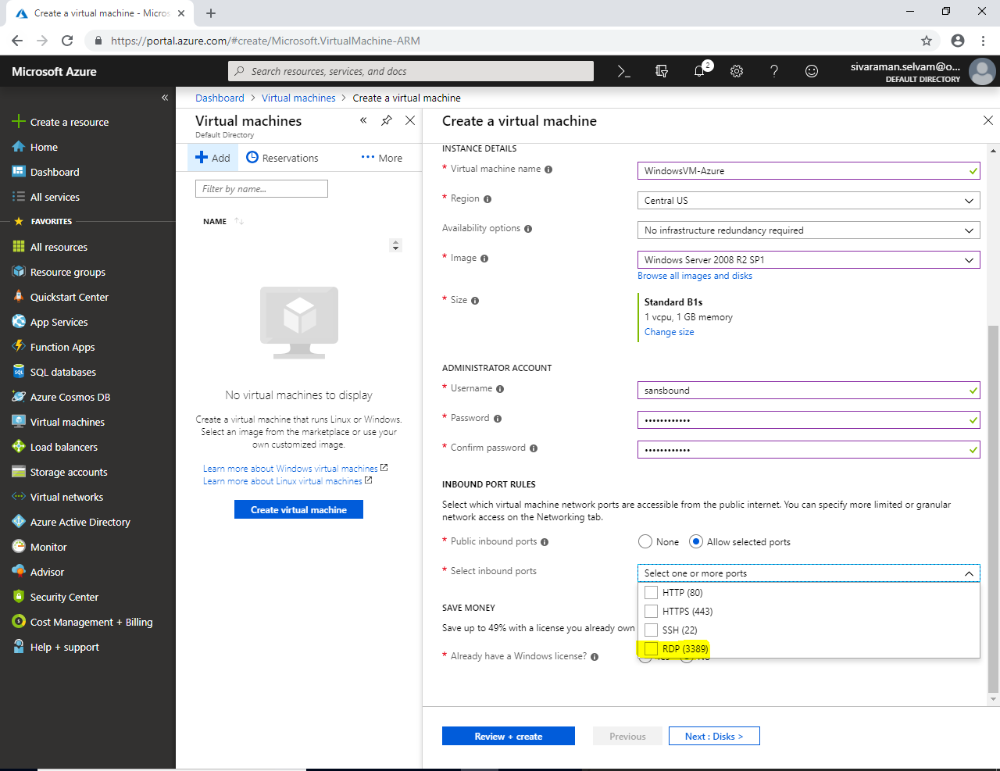

**As of now, we have allowed only RDP (3389) port to access the Windows Server through remotely.**

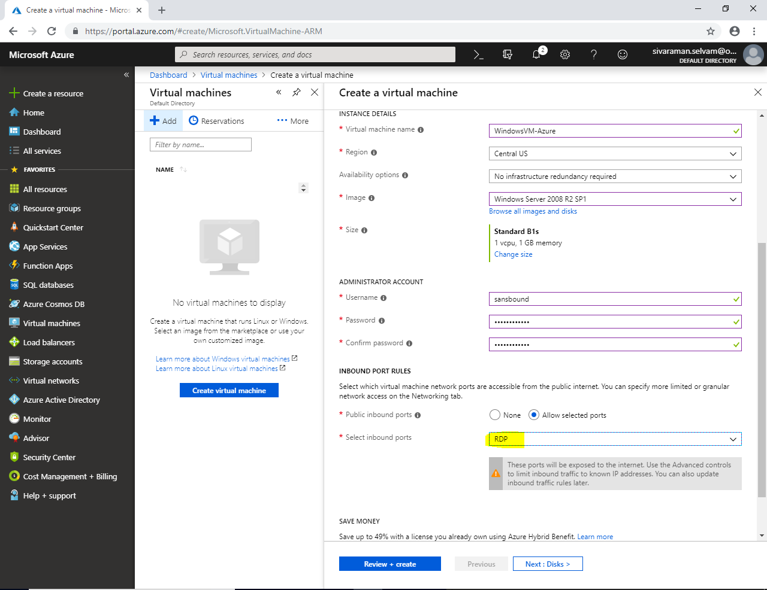

**In Save Money,**

**Click “Yes” that you have already have Windows license.**

**Also in “Confirmation” click the Check box.**

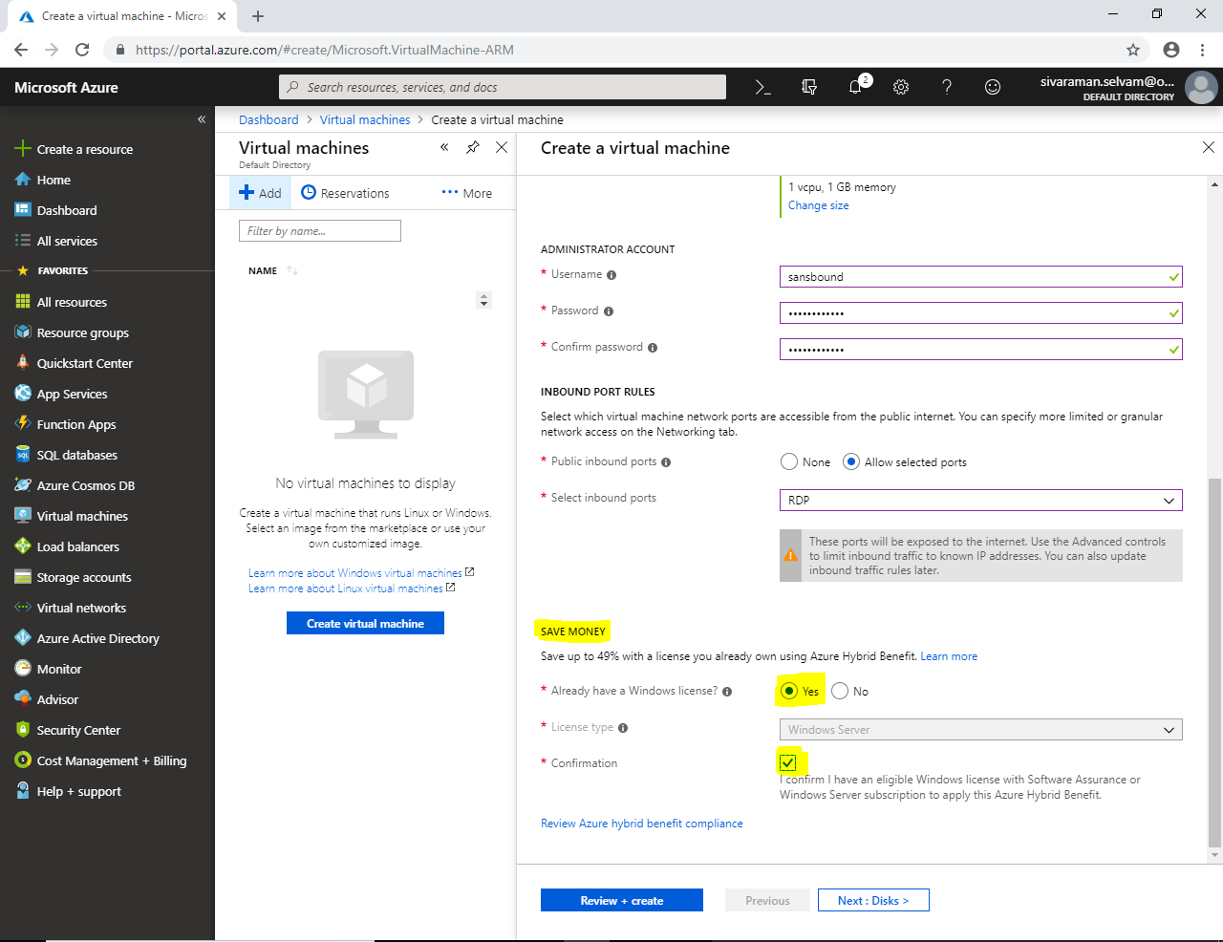

**At this stage, I will click “Review + Create”.**

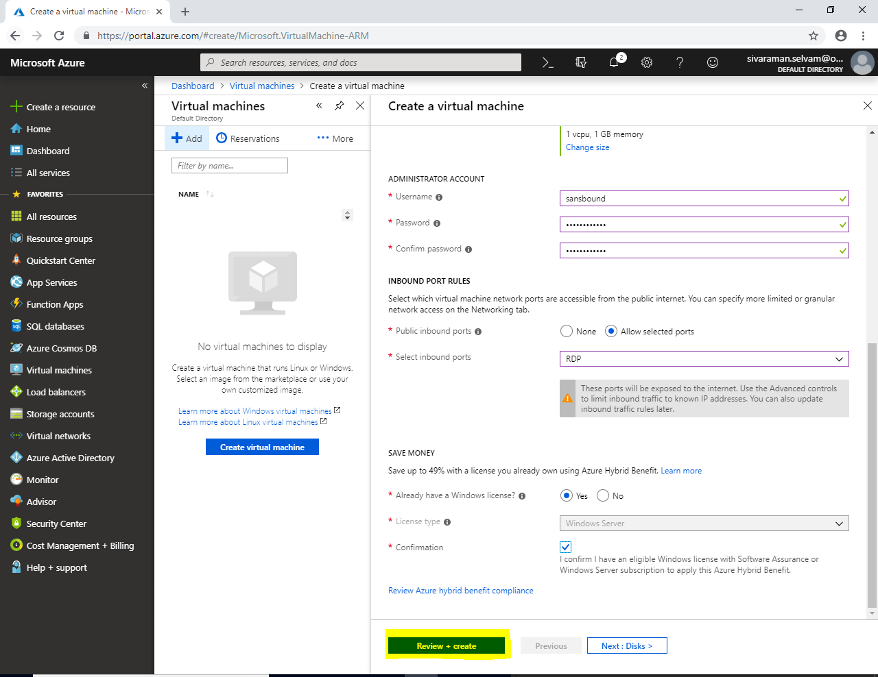

**Click “Create” to create Virtual machine.**

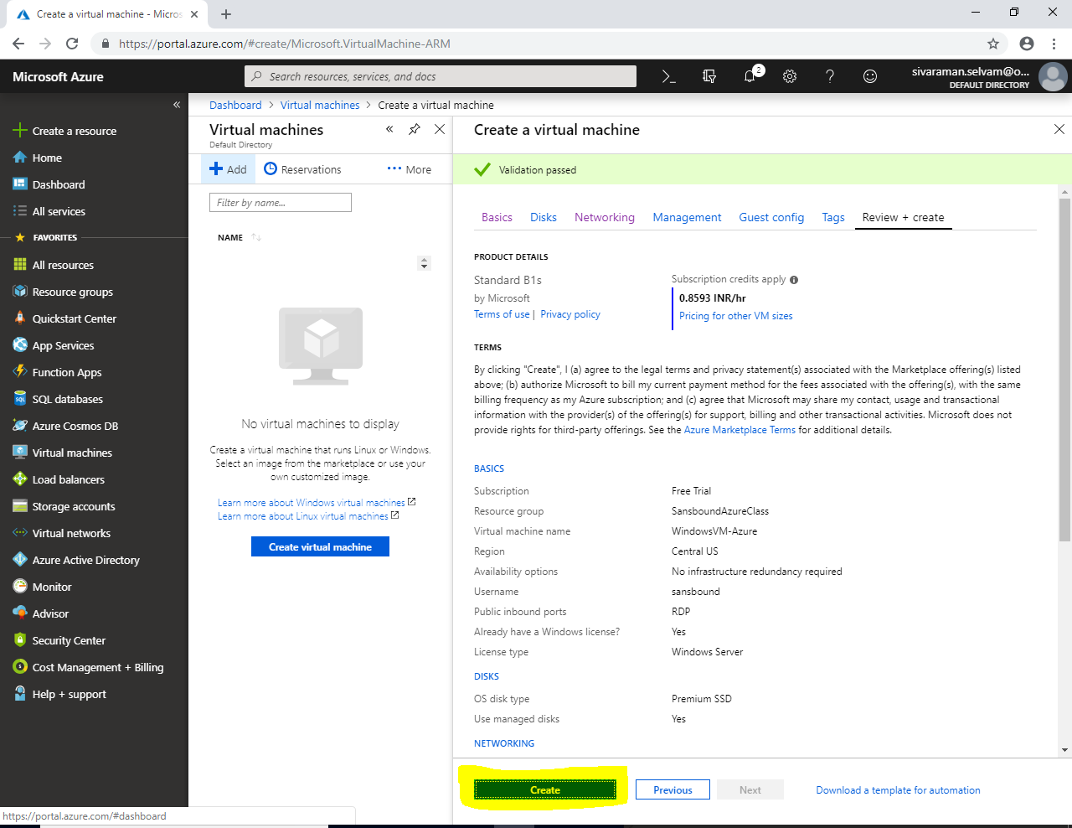

**Virtual machine creation in progress, we need to wait for some time. Please wait for 4-5 minutes approximately.**

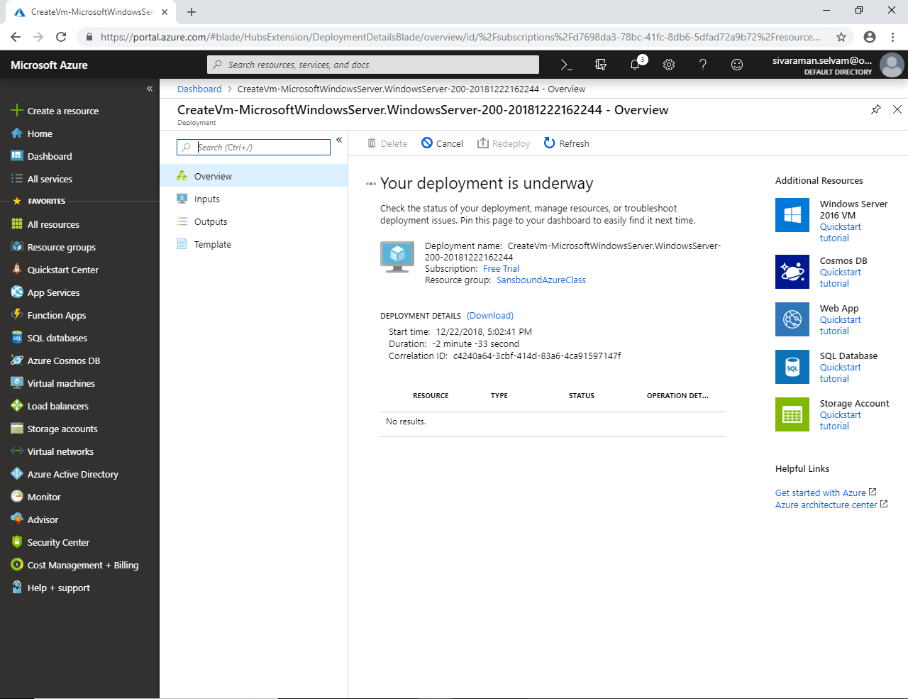

**Now your deployment has been completed.**

**Click “Go to resource”.**

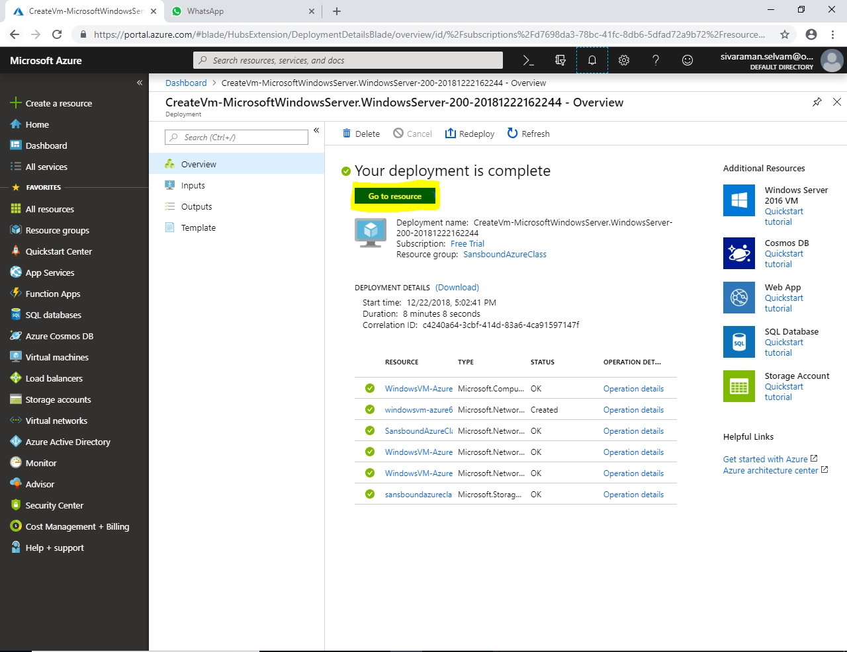

**Now we are in VM settings which has been created by us in the name of “WindowsVM-Azure”.**

**We have got below mentioned information in the Virtual machine.**

1. **Resource group details under which “Resource Group” has been created the VM.**
2. **Computer Name, Location and Virtual Machine Size.**
3. **Subscription type.**
4. **We have got Public IP for the Virtual machine (Our IP is 168.61.148.47).**

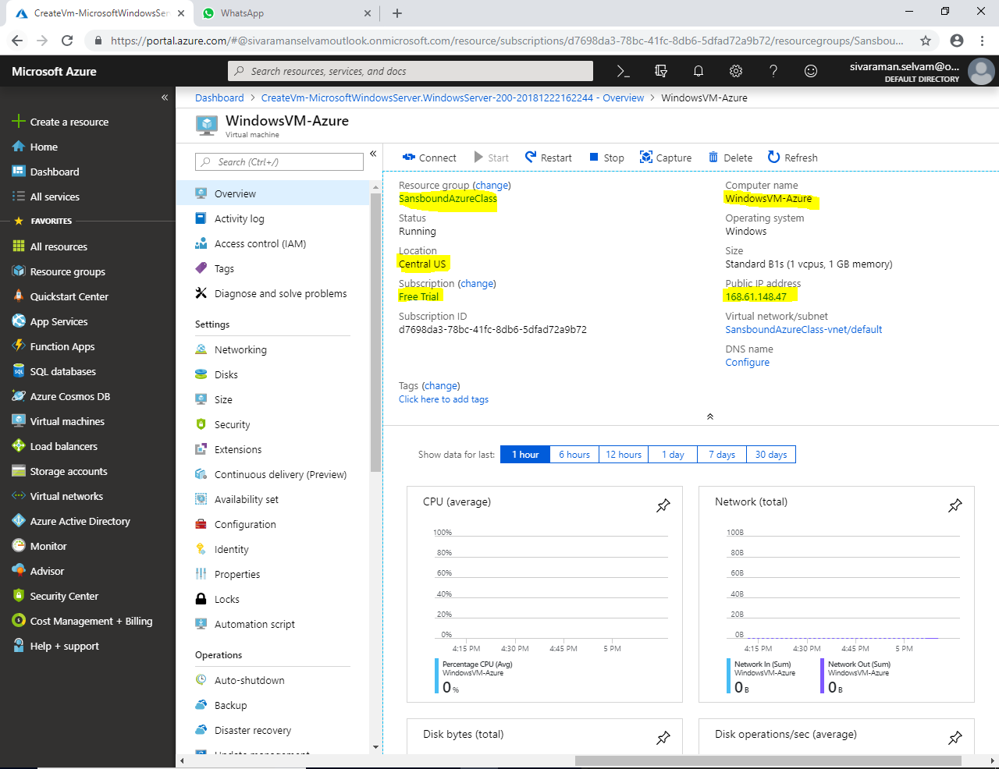

**From local machine / Physical machine, type “mstsc” in Run box to get console to access the server remotely.**

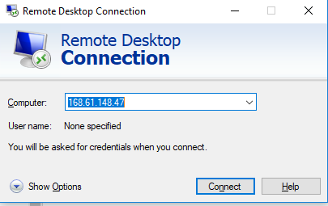

**Click “Connect”.**

**While click “Connect” it required login credentials to access the server.**

**Type username as “sansbound”**

**Type Password (Which you have provided in Azure Portal)**

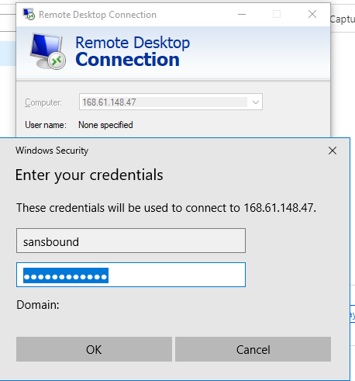

**Then Click “OK”.**

**And Check “Don’t ask me again for connections to this computer”.**

**Click “Yes”**

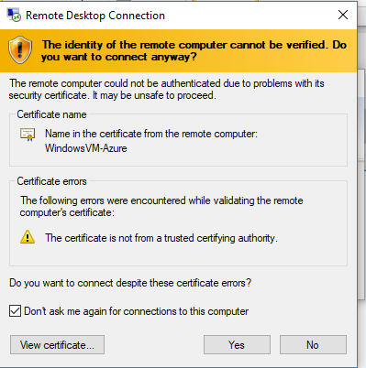

**I have successfully logged on to the “Windows 2008 R2” Virtual machine in Azure.**

**I have got the IP address details from command prompt by type “ipconfig”.**

**I have got the IP as 10.0.0.4.**

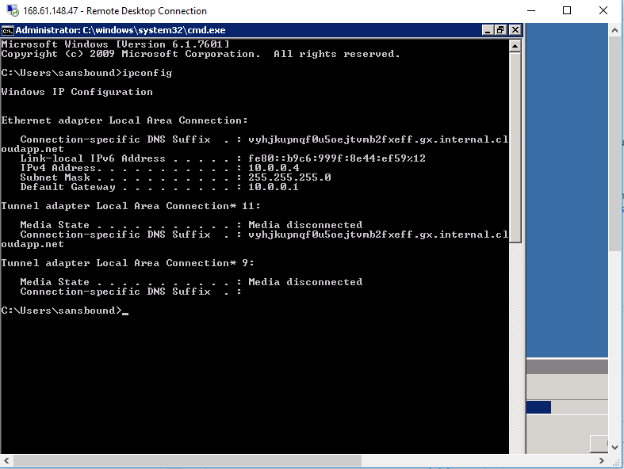

**By default internet access has been provided.**

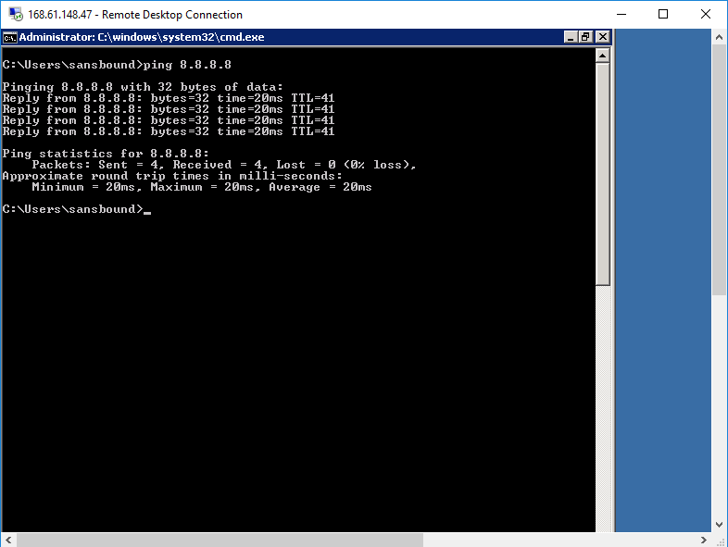

**Once you have shutdown the machine “Stop” button becomes inactive. It seems the VM has been Shutdown successfully.**

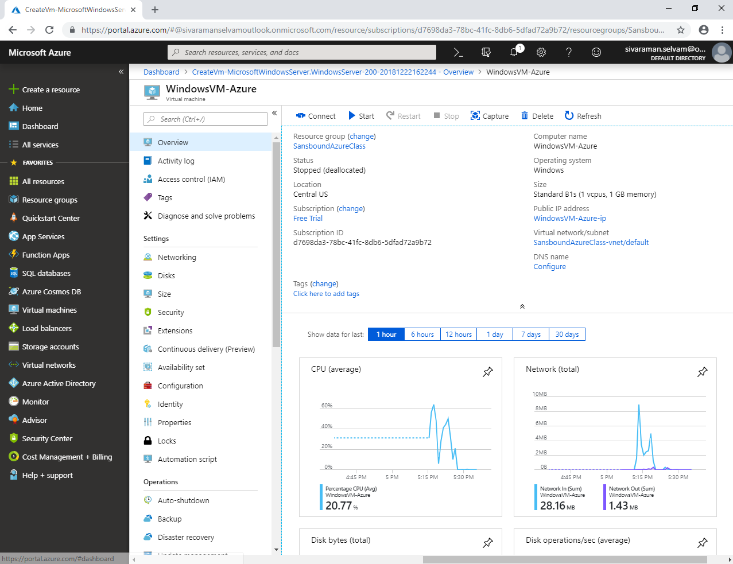

**In Dasboard, click “Resource Groups”**

**Select Resource groups “SansboundAzureClass” which you have required to delete.**

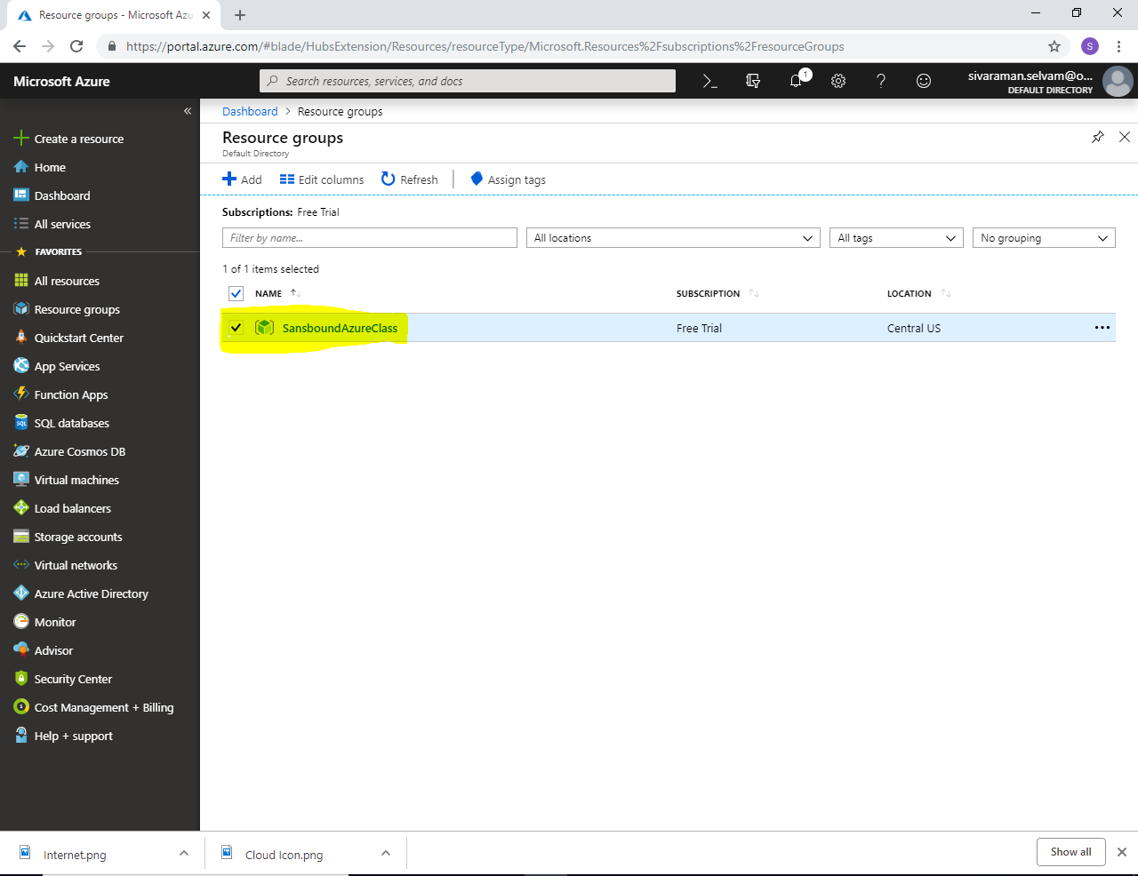

**Note: It’s not recommended to delete the Resource group it will delete the entire features which has been created under the resource groups.**

**But, we are in Free Trial subscription / Learning purpose. So we have delete the resource group to delete all features which has been created by us instead of manual deletion of the features.**

**Select Resource Group named “SansboundAzureClass” and right click it, then click “Delete resource group”.**

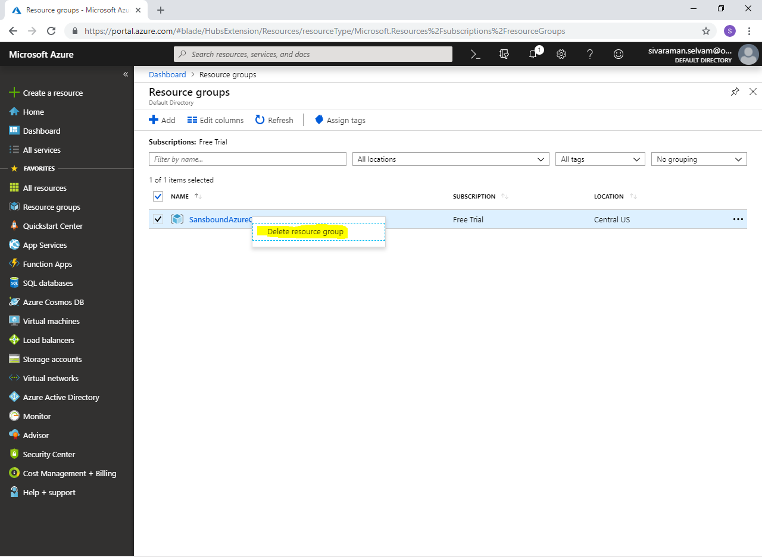

**Type Resource group name as “SansboundAzureClass”**

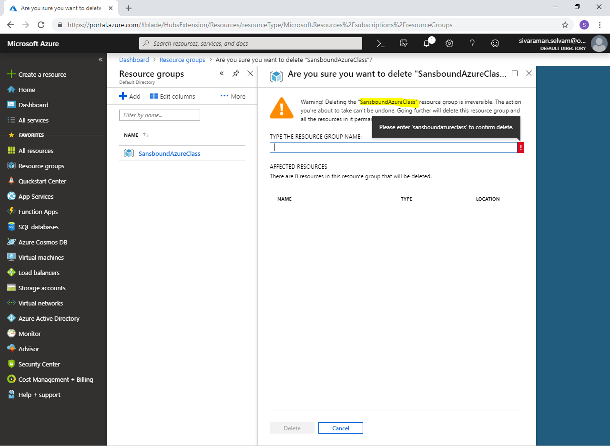

**Click “Delete” to delete the Resource group.**

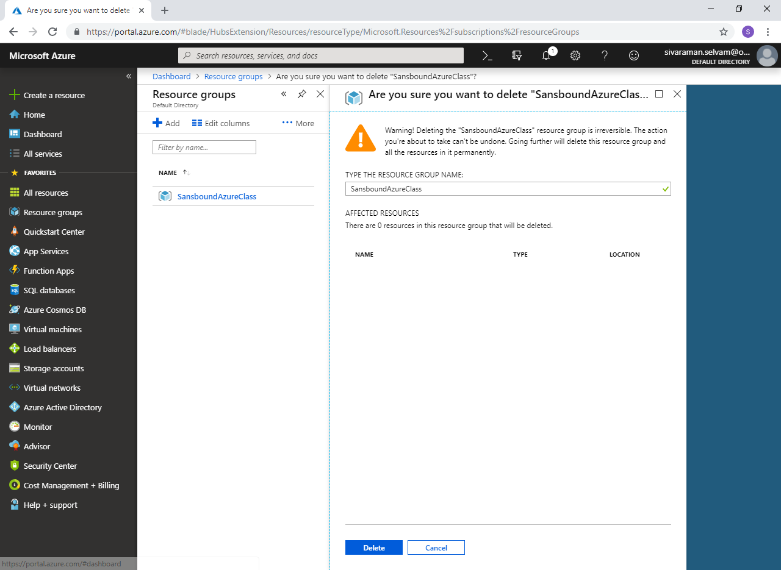

**Click “Refresh”.**

**Now the “Resource Group” has been deleted.**

